03/08/24

1)CREATING A HAS SET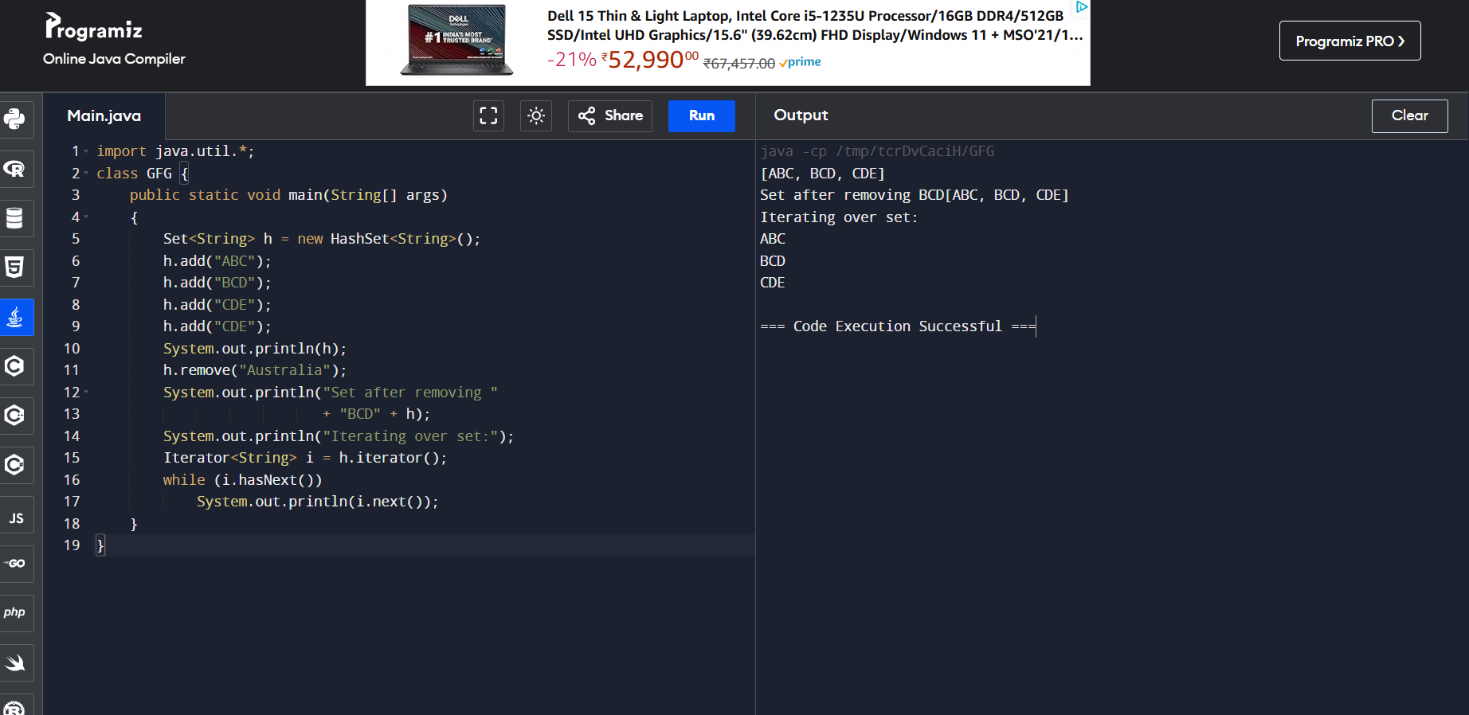

2)CREATING A LINKED HASH SET

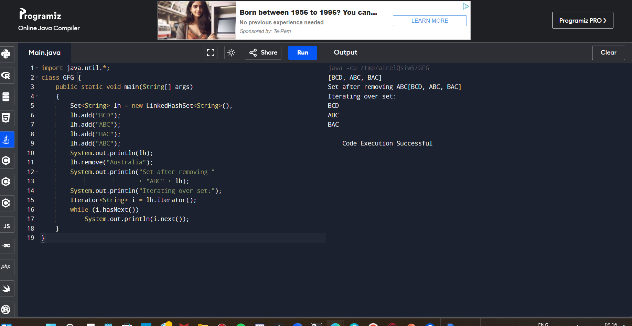

3)CREATING A TREE SET

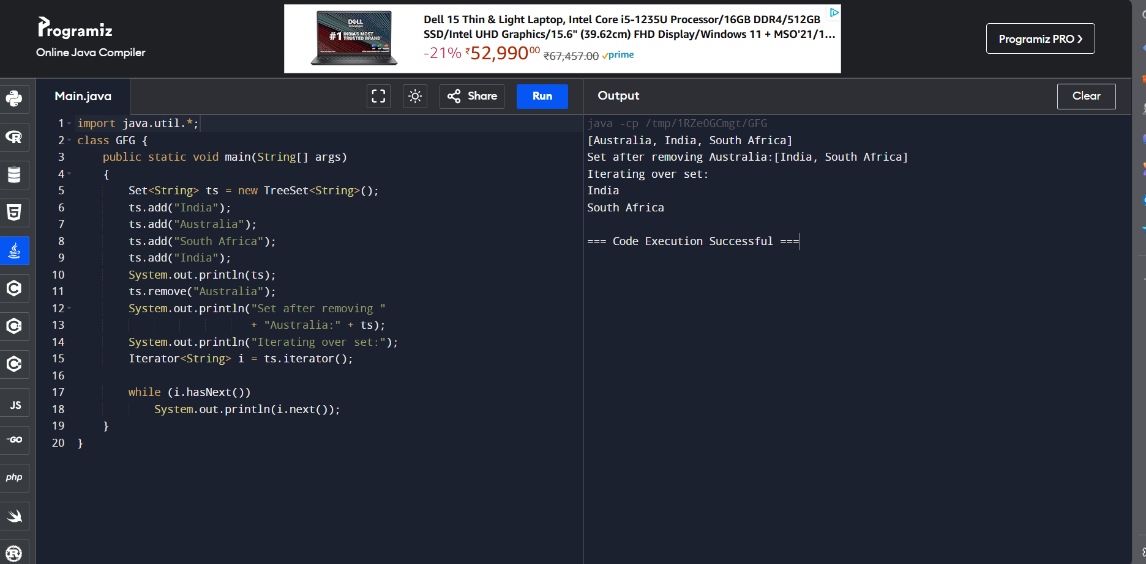

4)CREATING A CLASS USING STACK CLASS

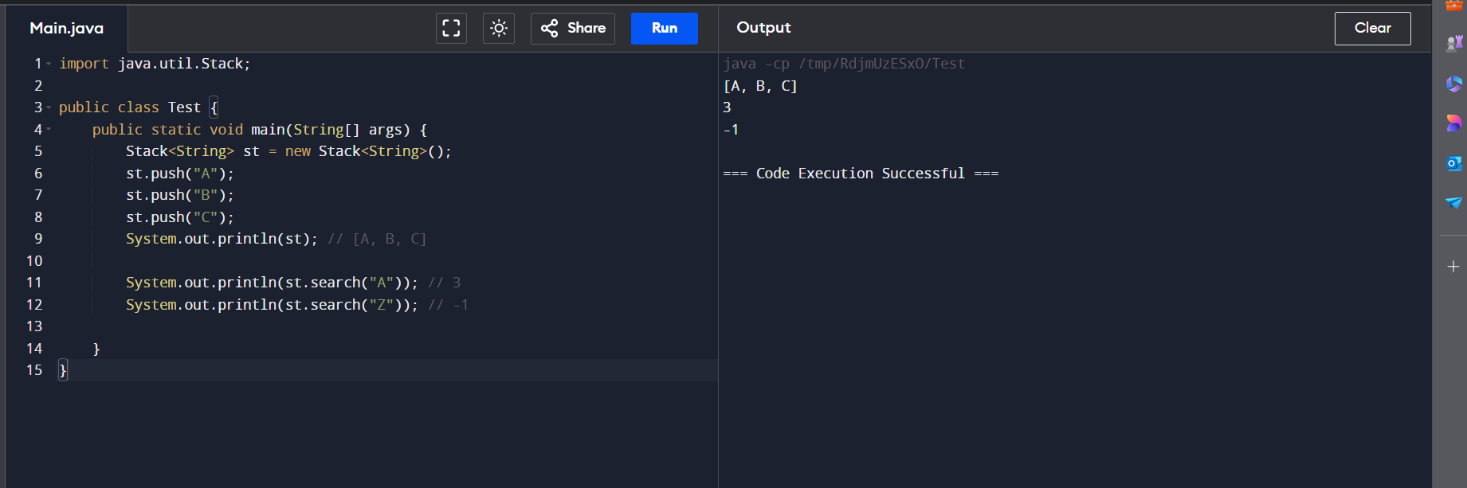

5)CREATING A CLASS USING LINKEDLIST CLASS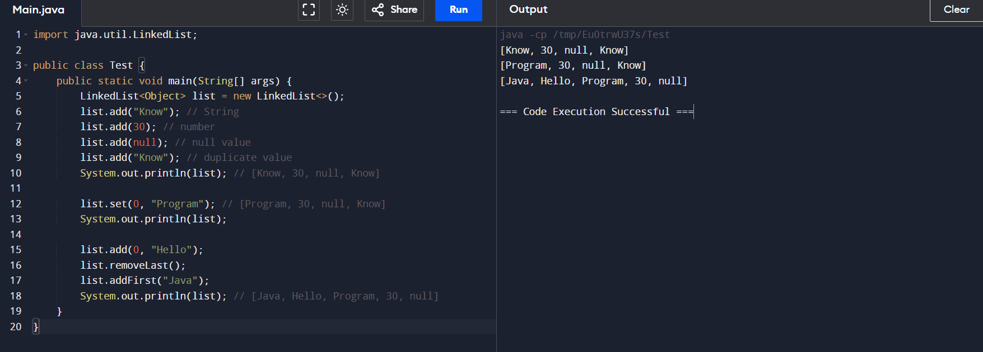

6)CREATING A LIST USING VECTOR CLASS

